Azure Project  
  
Phase 1:   
1. Create a Resource Group for organised management  
2. Create speech service in MS Foundry   
Key 1: 3Iav5RjeeN5aaOo7bvuNDY8IlQ0zah5DSKwWwH7zaX2qdYXYm0gIJQQJ99BKACqBBLyXJ3w3AAAYACOGLGHk  
  
Key 2:  
C6JBglVCiuZaUBoJIMRo1KIyZ2d0Fm9m1Fs45MTPDKDJ6EwxSI0OJQQJ99BKACqBBLyXJ3w3AAAYACOGEFeG

Region:  
southeastasia  
  
EndPoint:  
<https://southeastasia.api.cognitive.microsoft.com/>

3. Create Blob storage for audio file retrieval (Serverless built around)  
Storage account allows up to 500TB of data storage in the cloud.  
Hot & Cool access tiers help optimize cost based on frequency of usage.  
  
4. Created audio container in the storage account

5. Created a Function App as a serverless compute service  
6. Added the Speech to text AI Key value pairs to the environmental variables  
7. Created HTTP Trigger in VS Code; Azure Functions Project (Local virtual env)

8. Created the HTTPtrigger template code for use with the Azure Language Services API

9. Added the code for the HTTPtrigger

10. Could not seem to get the Azure function to run locally. Installing the core tools for local testing.

11. After installing core tools, got it running locally.

12. Testing via Postman with audio file attachment  
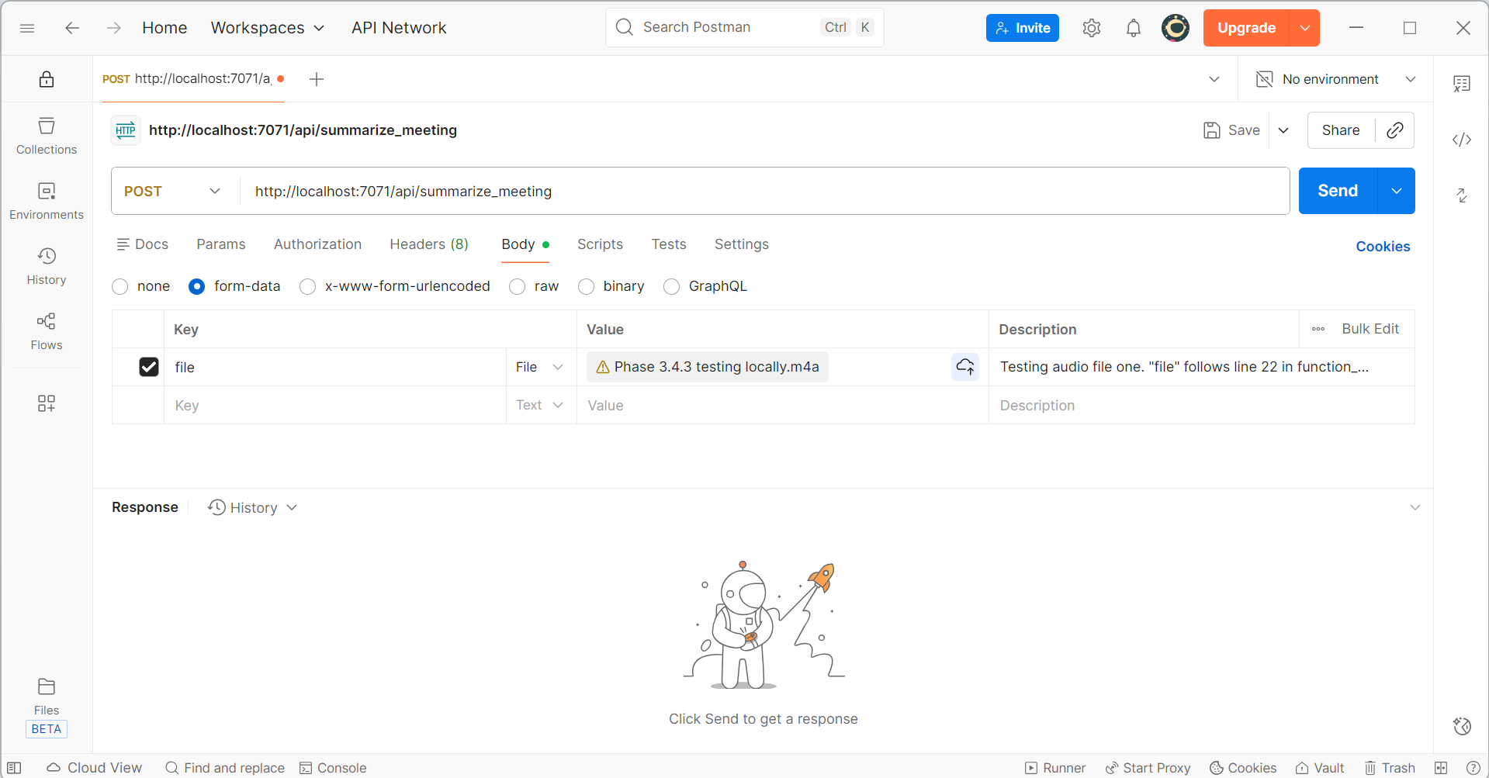

13. Local testing seems to work partially?

14. Created Language Service from Foundry  
Key 1:   
93yNJeORBwiXjNfy8KQCRs0u8ovrP2EdVwC9ueHV8ArwNLDkQacXJQQJ99BKACqBBLyXJ3w3AAAaACOGv5GZ  
  
Key 2:  
4JcuSw6DpTQR3bdZs0QPOBEs185RHptA9pNye1Xdr3rqXpOnPRO8JQQJ99BKACqBBLyXJ3w3AAAaACOG5F4x

Region:  
southeastasia

Endpoint:   
<https://meetingsummerizerlanguage.cognitiveservices.azure.com/>

15. Added Key & Region to Function App Environment Variables and Local Environment  
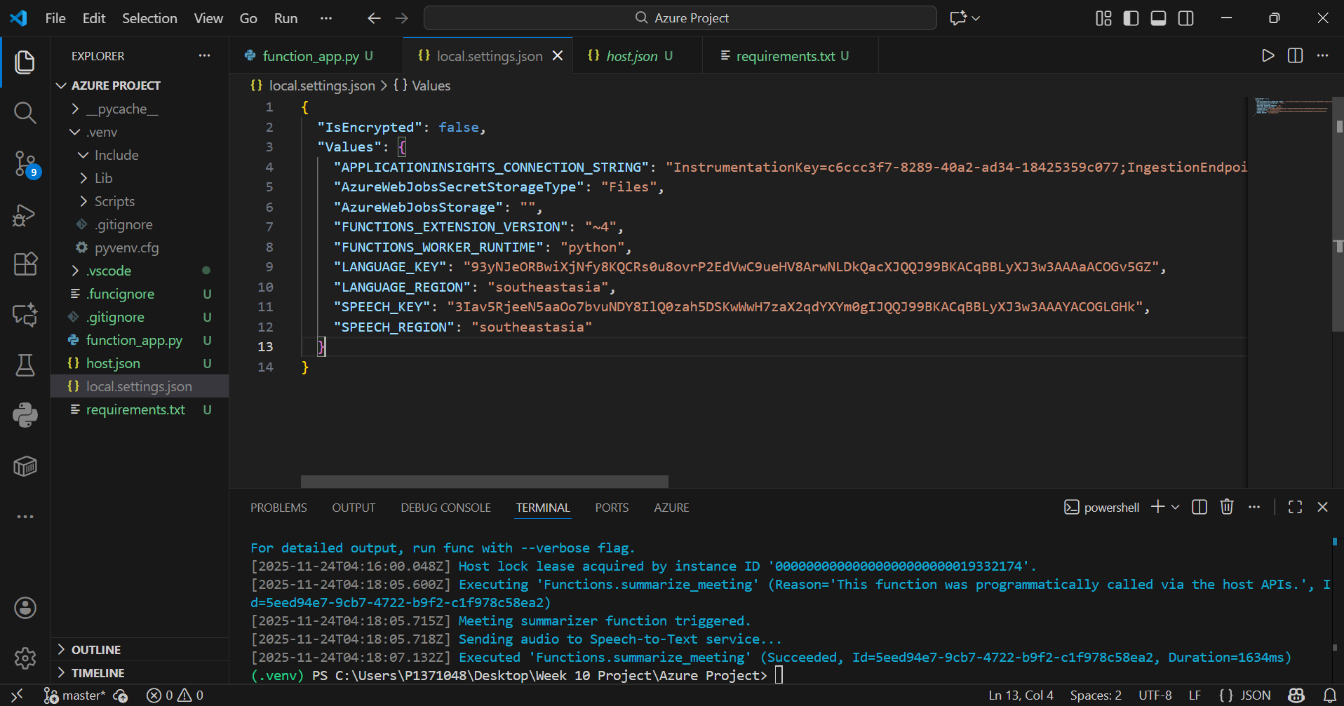

16. Re-initialized the venv due to library mismatch 

17. Refactoring how the audio file is being sent to the SpeechSDK for the Speech to Text service 

18. Found out the call for the Summarization API needs to be in a certain format.  

19. Formatted the payload to the expected format for the Language Summarizer API. Succeeded in the transaction. 

20. Made a simple frontend to test. 

21. Made the frontend presentable  
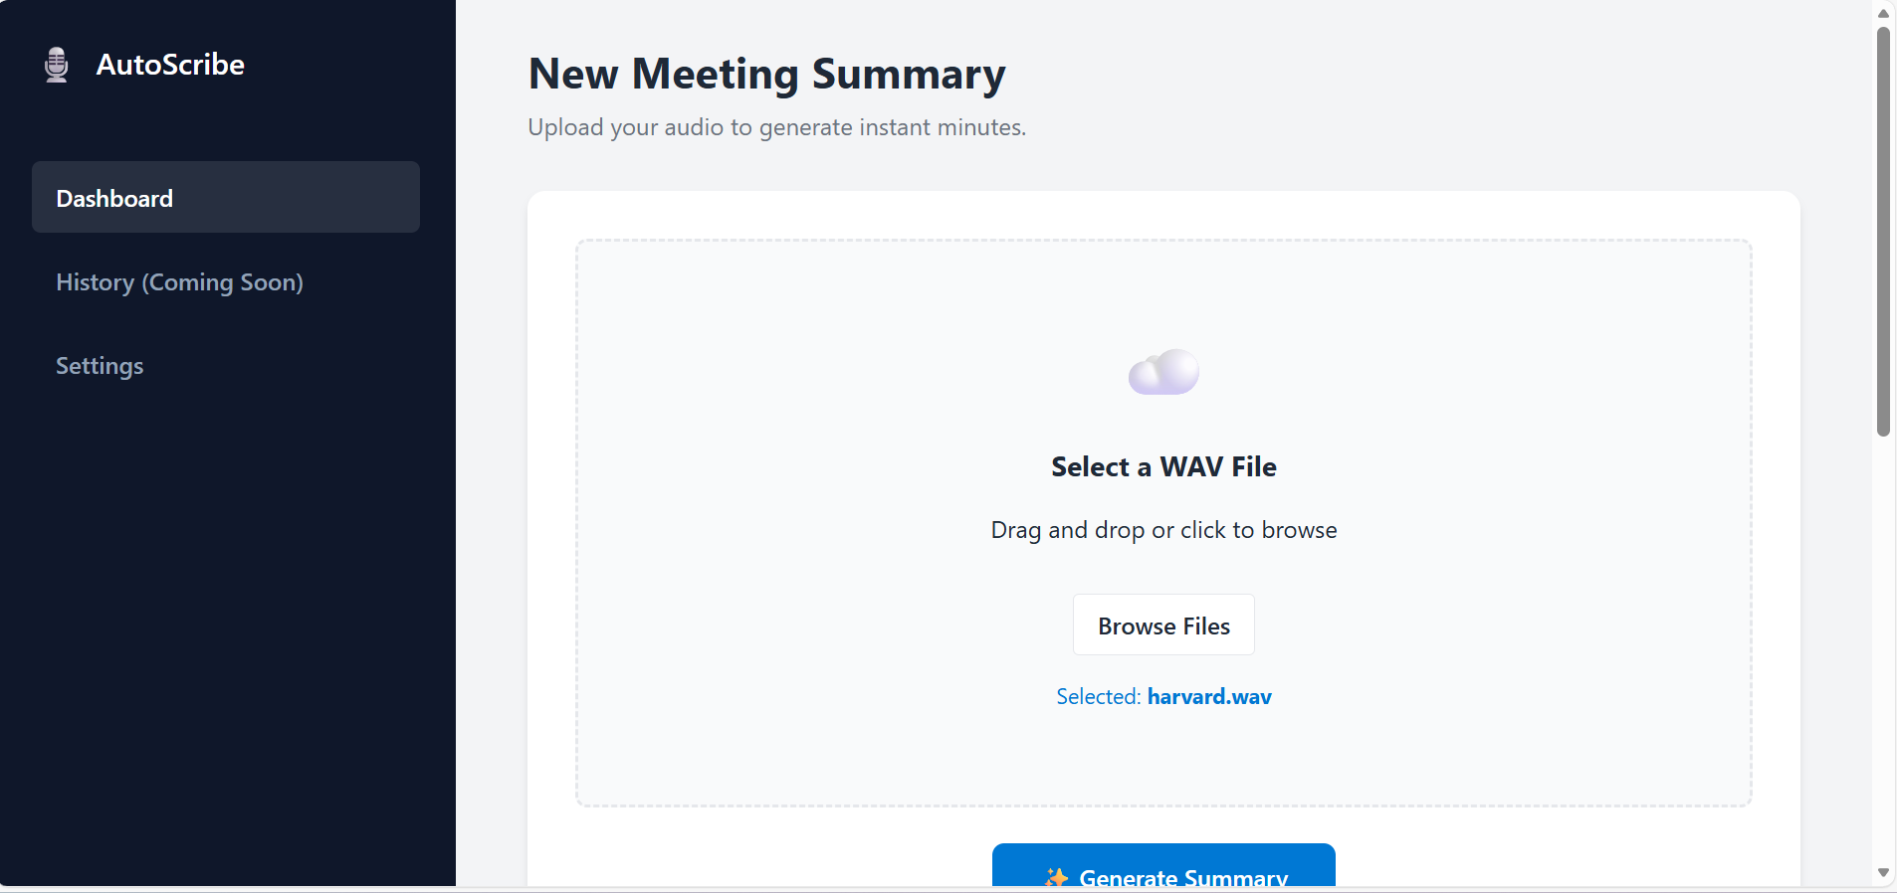

22. Modified the file reading and saving logic to be cloud safe and ready.  
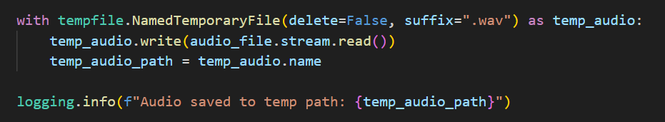  
Tempfile is used due to cloud not being able to have a ready file path to always read from.  
  
23. Error as tempfiles could not be deleted due to buffer being too long. Had to modify to delete immediately for process to work.  
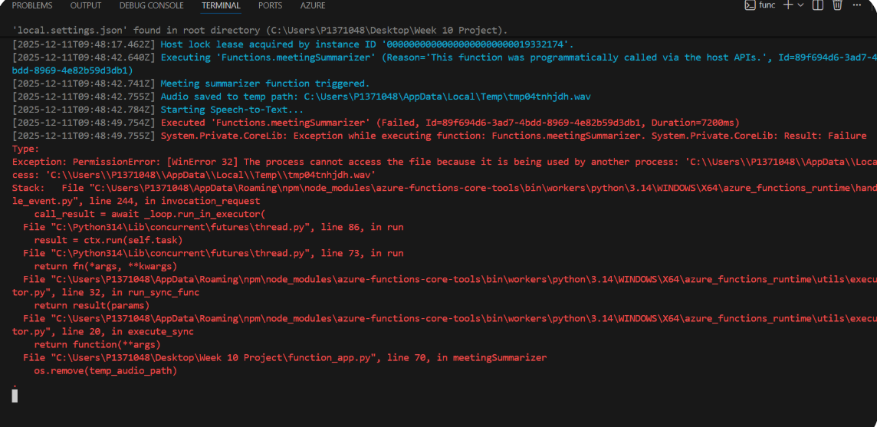  
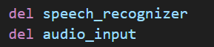

24. Deploying to Function App via VS Code  
https://tinyurl.com/mstjbn5w